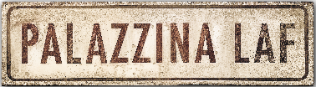 un film di MICHELE RIONDINO

CLIP e TRAILER

CLIP password unica: Palazzina_CLIP

Clip1 | Lettera Monsignore https://vimeo.com/871860480?share=copy
Clip2 | Ingresso Palazzina LAF https://vimeo.com/871860436?share=copy
Clip3 | Basile alla LAF https://vimeo.com/871860281?share=copy
Clip4 | Basile e Lamanna in macchina https://vimeo.com/871860347?share=copy
Clip5 | Dichiarazioni al magistrato https://vimeo.com/871860205?share=copy

TRAILER: https://drive.google.com/file/d/1USA8WY56kPsZTEoQVZ6s87RI1pYRVxq3/view?usp=sharing
TRAILER su YOUTUBE: https://youtu.be/xFoZSerreFI

ufficio stampa film:
VIVIANA RONZITTI ronzitti@fastwebnet.it +39 333 2393414
FABRIZIO GIOMETTI redazione@kinoweb.it

materiale stampa su: www.kinoweb.it

