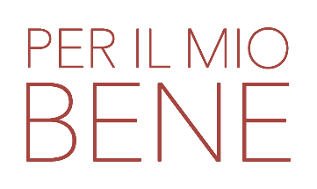un film di MIMMO VERDESCA

CLIP password unica: PERILMIOBENE

Clip1 https://vimeo.com/1028354499 (Bobulova)
Clip2 https://vimeo.com/1028357819 (Bobulova, Sandrelli, Ciocca)
Clip3 https://vimeo.com/1028361049 (Bobulova, Sandrelli)
Clip4 https://vimeo.com/1028364867 (Bobulova, Gullotta)
Clip5 https://vimeo.com/1028367238 (Barrault, Bobulova)
Clip6 https://vimeo.com/1028368488 (Barrault, Bobulova)

TRAILER
https://vimeo.com/1026538679?share=copy#t=0

TRAILER youtube
https://www.youtube.com/watch?v=TkS-m4jJ0ys

TRAILER MUSICALE youtube
https://youtu.be/dl_U5843ekQ

ufficio stampa film: VIVIANA RONZITTI ronzitti@fastwebnet.it | +39 333 2393414
FABRIZIO GIOMETTI redazione@kinoweb.it

materiale stampa su: www.kinoweb.it

