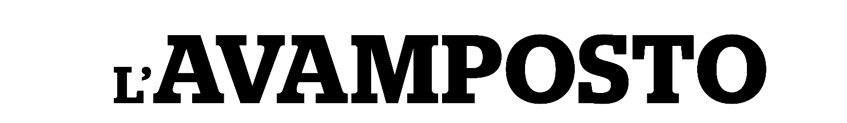 | CLIP
un film documentario di EDOARDO MORABITO

CLIP: password unica Clark2023

Clip1 | https://vimeo.com/857601987?share=copy
Clip2 | https://vimeo.com/857605248?share=copy
Clip3 | https://vimeo.com/857607706?share=copy
Clip4 | https://vimeo.com/857608935?share=copy

ufficio stampa film:
VIVIANA RONZITTI ronzitti@fastwebnet.it +39 333 2393414
FABRIZIO GIOMETTI redazione@kinoweb.it

materiale stampa su: www.kinoweb.it

